Exercise No: 10

Date: 19-11-2020

Aim:

To write a python program to print the number of upper case letters and lower case letters in a given string.

Program:

def string_test(s):

d = {"UPPERCASE":0, "LOWERCASE":0}

for str in s:

if str.isupper():

d["UPPERCASE"]+=1

elif str.islower():

d["LOWERCASE"]+=1

else:

pass

print("No. of Upper case characters: ", d["UPPERCASE"])

print("No. of lower case characters: ", d["LOWERCASE"])

s = input()

string_test(s)

Output:

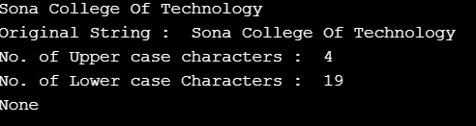

Link:

<http://103.53.53.18/mod/vpl/forms/submissionview.php?id=325&userid=1706>

Result:

Thus the number of upper case letters and lower case letters in a given string was calculated.